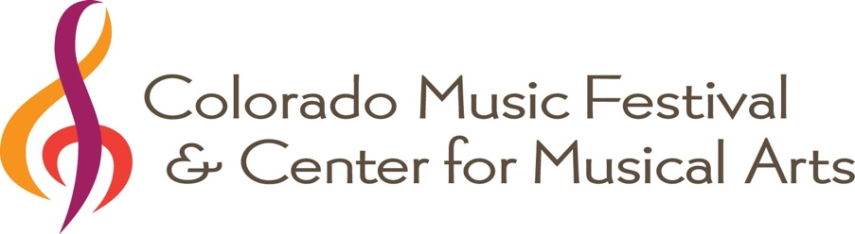

CMA HONORS RECITAL
GUIDELINES

Each spring, outstanding CMA students are chosen by audition to participate in the Honors Recital. The purpose and intent of the recital is to recognize and honor the hard work and accomplishments of CMA students. Participants in classes or ensembles are eligible, in addition to individual or group lesson students.

Emphasis is on celebration rather than competition, even though we require an audition in order to perform in this special recital. We are interested in students gaining a positive experience in performing, rather than a negatively critical assessment of their skills. The panel is aware of this, and will assess accordingly.

An outside panel of judges will score auditions, and students placing in the top scoring bracket will be invited to perform. Info/bios of judges will be available as soon as they are confirmed.

The Honors Recital is a celebration of CMA students, and is open to the general public. Students will receive certificates of accomplishment and plans are underway to video the recital as well as livestream the performance so that out-of-town family and supporters can be included. Performers will receive a link to the video file. A reception will follow the performance.

Requirements/Criteria:
- Students must be nominated by their teachers in order to audition. All areas of instrumental/vocal study are eligible.
- Teachers should review these guidelines and rubric(s) with students and parents before submitting a nomination.
- Students may elect to participate in the audition and not the recital in order to receive comments from the judges. We need to know before auditions whether students intend to perform or not.
- Auditions are open to students of any age or level, but students must have at least one semester of study at CMA, and must be currently enrolled for spring semester.
- Small ensembles are eligible.
- Audition repertoire should be 3-5” in length,
- Memorization is encouraged but not required.
- Missing one or more lessons between audition date and performance date may jeopardize inclusion in the Honors Recital.
- Students must provide 2 copies of repertoire for judges prior to auditioning.
- The piece performed for the audition must be the piece performed at the recital.
- Participation in the dress rehearsal/run-through is required.
- Performance attire should reflect a special event (not everyday school wear).
- Recital participants should expect to remain for the entire recital in order to support their colleagues as well as to be included in the post-recital photo and reception.
- The judges will be looking for students who demonstrate excellent preparation of a piece of music (including, but not limited to: musicality, accuracy, intonation, dynamics, tempo, technique, and stage presence).

Judges will be scoring in these general categories:
Intonation, Tempo, Dynamics, Musicality, Note Accuracy, Articulation, Phrasing, Tone Quality, Rhythmic Accuracy, and Stage Presence.

